Fossils in the Classroom
Guidebook

Created by
Jen Bauer and Maggie Limbeck

Fossils
What is a fossil?
Fossils are the preserved evidence of life in the past. There are a variety of definitions on how old a fossil needs to be to really be considered a fossil, this ranges from 500-5,000 years.

Types of fossils:
- Body Fossils: Preserved parts of a plant or animal. This includes bones, shells, leaves, and teeth.
- Trace Fossils: Preserved traces of plant or animal activity. This includes footprints, burrowing holes, root holes, and coprolites (droppings).

Fossilization
Fossilization is the process that turns the remains of a plant or animal into a rock. There are many different types of fossilization

- Original Material is occasionally preserved in fossils. Some shells retain their original aragonite and some bones (such as the skull in the famous T. rex, Sue) still have some of the bony material intact.
- Replacement - some types of skeletal material, such as aragonite in seashells, naturally change into harder, easily preservable substances, such as calcite.
- Molds - sometimes a bone or shell is covered by dirt and then decays. The hole that is left behind is called a mold; footprints and skin impressions are special instances of molds.
- Casts - when a mold is later filled in by some other substance, the natural replica of the original organisms is called a cast.
- Carbonization - If a plant or animal is buried and then subjected to great pressure, the carbon that is within every living creature on Earth is sometimes compressed into a compact replica of the original organism; we most often see carbonization in plants.
- Petrification - some parts of living things, such as bone and wood, have holes in them which minerals can crystallize and preserve the substances around them. A great example of this is petrified wood.

What gets fossilized?
Not every part of animals has the same ability to be fossilized. Most animals have hard parts, such as your skeleton, and soft parts such as your skin, organs, and eyeballs. Things that are hard like our skeletons or shells have a much better chance of being preserved in the fossil record. Once an animal dies, the soft parts often start to decay or are eaten by other animals. As the fossilization process takes time, the soft parts are often gone by the time the hard parts get preserved.

Glossary

Throughout this guidebook we will use a series of terms describing how these animals lived long ago. We will define the terms here to start and will provide reminders throughout the text.

Extinct: No longer alive; an entire species has died out.

Extant: Still alive today; surviving..

Sessile: A term to describe an animal that is not mobile; the animal is stationary throughout some or all of its life.

Epifaunal: A lifestyle that involves living on top of the sediment in the ocean.

Infaunal: A lifestyle that involves living within the sediment in the ocean, this includes burrowing animals.

Benthic:Describes animals that live on the bottom of the sea floor.

Planktic: Describes animals that live passively within the water column.

Nektic: Describes animals that live actively by swimming through the water column.

Fauna: Describes animals that lived in a community at any given point in time.

Colonial: Animals that are made up of many interdependent organisms of the same kind that live in one body.

Solitary: Describes animals that live on their own as an individual.

Animalia
Mollusca > Gastropoda
Gastropoda fall under the larger grouping of Mollusca. The common name for gastropods is snails. Gastropoda loosely translates to stomach-foot in Latin.
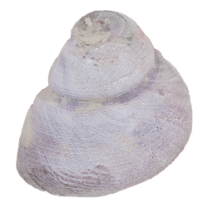
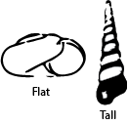
Gastropoda is an extant grouping with many extinct forms and a lot of variation through time. Gastropods may have a tall (conispiral) or flat (planispiral) spiralling growth pattern. They can live on land, in the water, or even in trees. Their ability to live in a wide variety of environments makes snails one of the most impressive animal groups. Gastropod fossils are most often preserved as molds. Moldic preservation means that the shell material is no longer present but rather an imprint or cast of the original material remains. This form of preservation does not often leave fine details of the original shell.

Mollusca > Cephalopoda
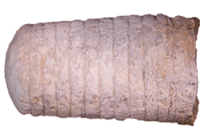
Cephalopods also fall under the larger grouping of Mollusca. Organisms that are grouped under cephalopods include modern creatures such as: squids, octopods, and cuttlefish. Cephalopod loosely translates to head-foot in Latin.

Cephalopods are still alive today (extant) and are a group of fast-moving nektonic (swimming) carnivores. This group either has an internal shell (like squids) or an external shell (Nautilus and many extinct forms). The shell of cephalopods is divided into many numerous compartments which are connected by a fleshy tube that runs through these compartments called a siphuncle. The main function of the siphuncle is to regulate buoyancy within the shell, which helps the organism swim and remain balanced in the water.
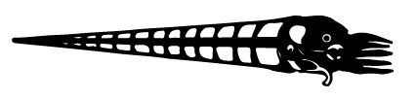

Mollusca > Bivalvia
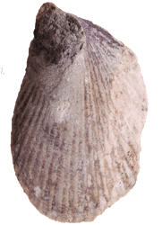
Bivalves also fall under the larger grouping of Mollusca. Organisms that fall within Bivalvia include modern creatures like clams and oysters. Bivalvia loosely translates to two valves (shells).

Bivalvia is an extant group of two shelled organisms that have variable lifestyle habits - some live in the sea floor sediment (infaunal), above the sediment (epifaunal), or even attached to rocks or other organisms! Often, you can tell their lifestyle by the shape of the shell. Infaunal organisms will be longer and narrower, which helps them poke out a little bit to get food. To feed from within the sediment, they use a siphon to suspension feed - the siphon takes in water and filters out the food from within it.
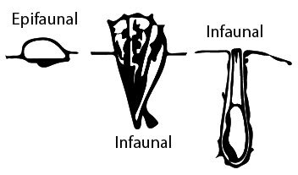

Lophophorata > Brachiopoda
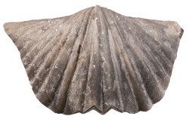
Brachiopods have two shells and look similar to clams. Brachiopods are an extant group of benthic (meaning, bottom dwellers) invertebrates. Although very few groups remain today, brachiopods were a dominant part of the Paleozoic (542-251 million years ago) fauna. At the end-Permian extinction, about 250 million years ago, many brachiopods went extinct. This large dying event allowed for the bivalves to move into the unoccupied ecological space and thus, bivalves became a much larger part of the later faunas.

Brachiopods have a lophophore (pronounced: low-pho-four), which is their feeding apparatus. The lophophore creates a current, drawing in water to the organism. As brachiopods are sessile (non-mobile), this allows the brachiopods to filter feed out of the water column.

Although brachiopods look similar to clams and even have two shells, their symmetry is different. Brachiopods are symmetric through the shell while clams are symmetric through the hinge of the shell.
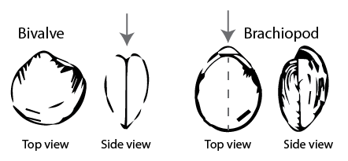

Lophophorata > Bryozoa
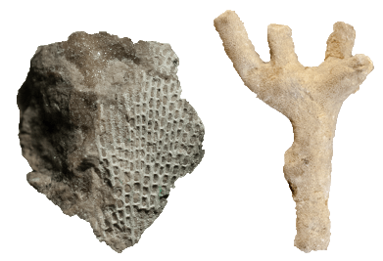
Bryozoans are tiny animals that build large structures to house many of the same organism. We call these large structures colonies of bryozoans. These colonies take many forms such as free standing mounds, branches, or they may encrust (grow on top of) the shells of other animals.

Although bryozoans resemble corals, they are most closely related to brachiopods. Like brachiopods, bryozoans also have a lophophore, which allows them to filter feed from the water column. Similar to brachiopods, bryozoans were more dominant during the Paleozoic and are less common in the oceans today.
Porifera
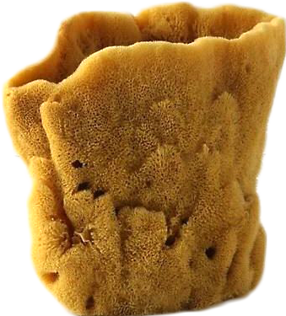
Porifera is the major group that contains sponges. Sponges are among the simplest of multicellular life forms to inhabit the oceans - but they are by no means simple! Sponges have the ability to regrow themselves when they are torn apart. Sponges have numerous holes through its skeleton (which is typically a simple cone or cylinder with a hollow central cavity), which bring in water and nutrients.

Sponges through time have constructed their body from calcite, silica, or spongin. Spongin is an organic protein, this make it easy to degrad or decay. Spongin is what the common natural sponges are made of (pictured here).

Porifera > Demospongia
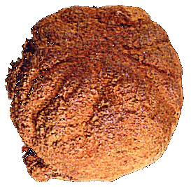
Sponges are extant and are some of the oldest living organisms on Earth. Many sponges live in clear, quiet, calm waters. Unfortunately, some sponges have a skeleton of spongin (an organic material), and do not readily preserve in the fossil record. These sponges are called demosponges.These fossils often look like unidentifiable round pebbles.

Other sponges that construct their skeleton of either calcite or silica preserve much better in the fossil record, because those minerals are much tougher and can resist the fossilization process.

Cnidaria
Cnidarians (nye-dare-ians) is the large grouping which contains modern creatures such as corals, sea anemones, and jellyfish. As sea anemones and jellyfish are made of soft parts, they have a poor fossil record. Here we will focus on Anthozoa, which includes the three major groups of corals: (1) Rugosa; (2) Tabulata and; (3) Scleractinia. Corals, in general, passively feed from the water column. These three groups of corals lived during different times in Earth’s history. Coral reefs today, and in the past, are biodiversity hotspots. This means that there are many different forms of life all in one place, making it a very valuable environment.

Cnidaria > Anthozoa > Tabulata
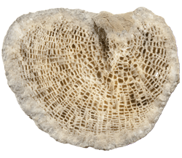
Tabulata was a group of corals that can be identified by the presence of tabulae (horizontal lineations), giving the fossil almost a ‘checkerboard’ appearance in side view. These corals went extinct at the end of the Permian (251 million years ago). The top of tabulate corals often look like many small hexagons, these are called corallites and is where the actual animal lived.

Cnidaria > Anthozoa > Rugosa
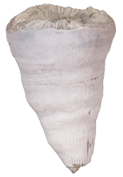
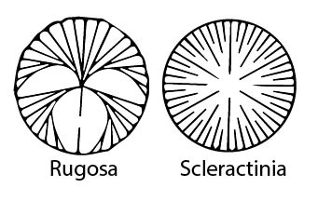
Tragically, Rugosa are an extinct group of corals that also went extinct at the end of the Permian (251 million years ago). Rugose corals can be solitary (a single individual) or colonial (multiple individuals living together interdependently). The solitary corals look like small horns and are often mistaken for dinosaur teeth! You can distinguish these corals from teeth by looking at the corallite (large round opening) and identify the septa (which radiate out from the center, giving it a wagon-wheel appearance).

Cnidaria > Anthozoa > Scleractinia
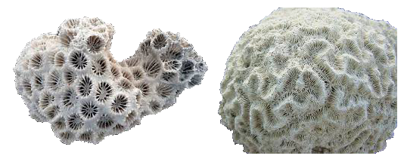
Scleractinian corals are those that are alive today! This group of corals is unlike the two extinct groups because their skeletons are made of a different material. They come in many shapes and sizes (brain corals, branching corals, etc.). These have septa similar to the rugose corals, but are arranged differently. Scleractinian corals make up all of the modern coral reefs, including the Great Barrier Reef.
Arthropoda
Arthropoda is a very large and diverse group. Modern animals include all insects, spiders, crabs, lobsters, crawfish, and other similar animals. All of these animals have a different kind of skeletal system called an exoskeleton. This means the hard skeletal parts are on the outside of their bodies rather than the inside (endoskeleton). Although there are many groups of arthropods, we focus on the trilobites that were abundant marine animals during the Paleozoic.

Arthropoda > Trilobita
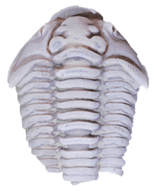
Trilobita is a grouping of organisms which falls under the larger grouping of Arthropoda. Arthropods include organisms such as insects, spiders, crabs, and more.

Trilobites are an extinct group of mobile, primarily benthic (bottom dwellers) carnivores and detritivores, eating both other sea creatures and particles floating in the water. Like many arthropods, trilobites have an exoskeleton. This inflexible exoskeleton requires the organism to molt (shed and grow a new, slightly larger one), just like lobsters and other arthropods today. Molting organisms leave behind a well-documented fossil records. Each molt has the potential to be preserved and many organisms molt many times during their lifespan! This means that one organism can leave behind many fossils.
Most fossils of trilobites are not the animals themselves. Most are molts from when the trilobite shed its outer shell when it grew.

Echinodermata
Echinodermata is a large, diverse group of animals that have changed dramatically through time. Modern echinoderms include sea stars, sea urchins, sea cucumbers, and brittle stars. Echinodermata translates loosely to ‘spiny skin’ - a reference to the spines that many echinoderms possess. Echinoderms are made up of many small hard parts that are held together by soft parts. Once the animals die, their hard parts fall apart very quickly. A single sea star has millions of skeletal parts that become part of ocean sand. We will focus on a few main groups here but it is important to understand there are many more.

Echinodermata > Echinoidea
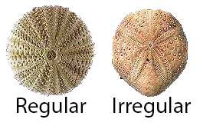
Echinoidea includes modern animals such as sand dollars and sea urchins. There are two main types of Echinoids that we will focus on here. One is called Regularia and the other Irregularia, these groups are just as they sound - Regularia are ‘regular’ meaning they have five-fold symmetry (like a starfish) whereas Irregularia have bilateral symmetry (like a butterfly). Echinoids are active feeders, which means that they are mobile and search for their food. Strangely enough, echinoids also have teeth!

Echinodermata > Crinoidea
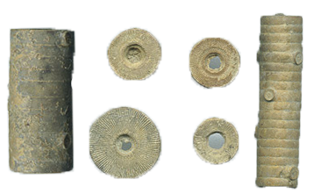
Crinoidea is a grouping found within the larger Echinodermata. The common name for crinoids is ‘sea lilies’, as they are often mistaken for plants.
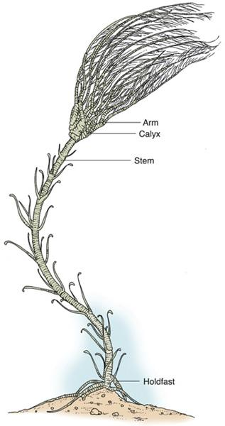
Crinoids are extant (alive today), although modern crinoids are very different than those of ancient times. The crinoids living today occupy the deep waters, whereas in the past, crinoids lived in shallow seas. Crinoids have a main body, arms, a stem, and a holdfast keeping them rooted to the sea floor. The arms and stem consist of many smaller skeletal elements. The arms of crinoids can extend out and create a large fan to aid in catching food particles as the water passes over them. Soon after death, all of these small plates fall apart. In the fossil record, it is very common to find pieces of stems or just the ossicles (small round parts that make up the stem). The ossicles are easy to identify as they often resemble Cheerios!
Vertebrata
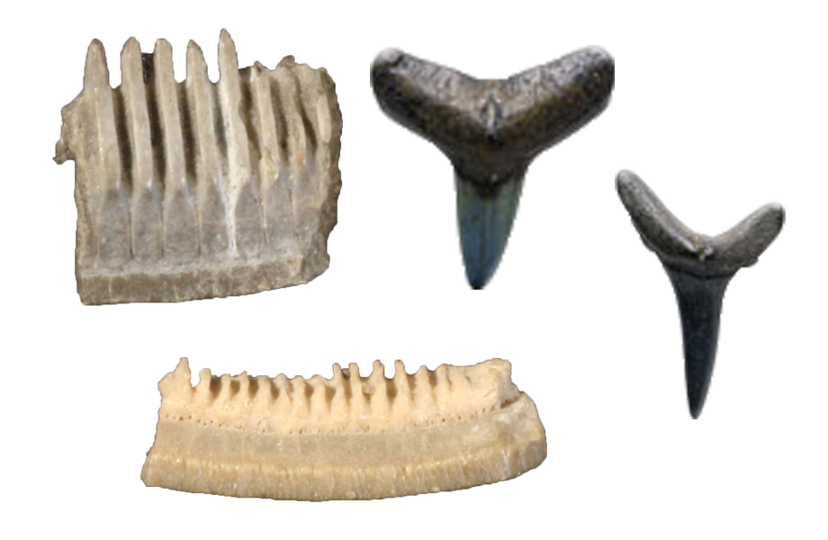
Vertebrates include all animals with bones (most of the fossils described here have been invertebrate animals, or animals that do not have a spinal column). Throughout time, marine (aquatic) invertebrates are in higher abundance. This is because it is easier to be preserved if you are underwater in a very secure environment that always has new sediment forming on the ocean floor. Vertebrates includes animals such as fish, reptiles, amphibians, birds, dogs, cats, humans, and dinosaurs.

In the fossil record, it is common to find teeth of vertebrate animals or bone fragments. Once the fleshy soft parts decay the hard bones and teeth often fall apart since the soft parts are what hold them together. Most of the vertebrate fossils in Tennessee are fish, sharks, mosasaurs (aquatic reptiles), and other seagoing animals. The only dinosaur ever found in Tennessee is a hadrosaur. Scientists believe that it died and floated out to sea where it sank and fossilized underwater. From the Pleistocene Period (the Ice Age), fossils of tapirs (pig-like animals) and giant sloths were recently discovered in Tennessee. Among these extinct animals, other modern vertebrates such as snakes, turkeys, alligators, and frogs were also found.

Plantae
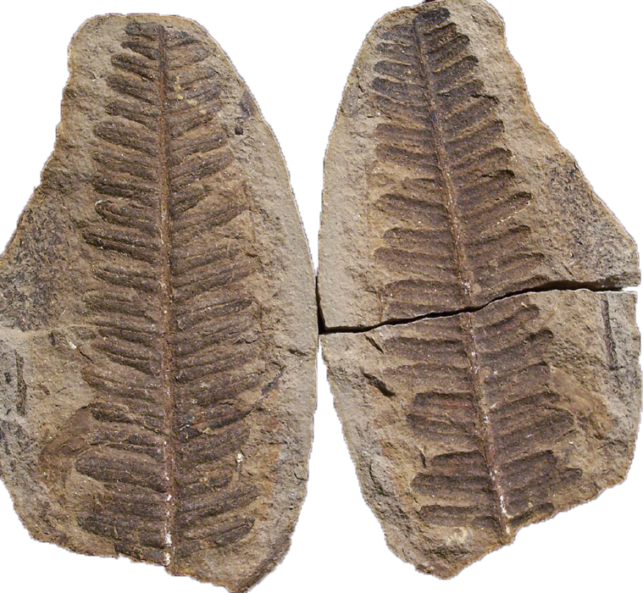
When most people think about of fossilized plants, they think about petrified wood. However, you can find fossils of leaves, seed pods, tree trunks, flowers, and even pollen grains!Scientists can use plant fossils, particularly pollen, to understand past climates. If a scientist finds pollen from tropical plants, the area where it was found must have been tropical in the past. Dig sites that yield pollen from plants from colder climates must have been under colder conditions at the time.

Plants that are common in Tennessee are from the Carboniferous (360-299 million years ago) and are remnants of an ancient swamp environment.

Plants often preserve in a form of moldic preservation called imprints. This can be in dark rock called shale or even coal or hidden within concretions. Concretions form from micro-environments created by bacteria eating the plant material and excreting (pooping) out other elements. This alters the chemistry around the decaying leaf or plant matter. The concretion can then break open revealing the plant fossil inside.

For these materials and additional materials, please go to the QR code pictured below or type this link into your web browser:

https://github.com/jenebauer/Fossils_in_the_Classroom


